**Graph Data Structure and Algorithms.**

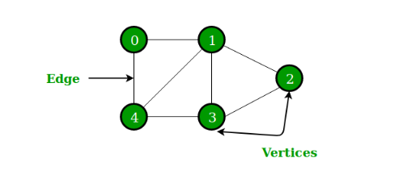

**Edge: - edge is represented by a line or arrow extending from one vertex to another.**

**Vertices: - one of the points on which the graph is defined and which may be connected by graph edges**

**Types of graph: -**

1. **Directed Graph: -** A directed graph also referred to as a digraph, is a set of nodes connected by edges, each with a direction.

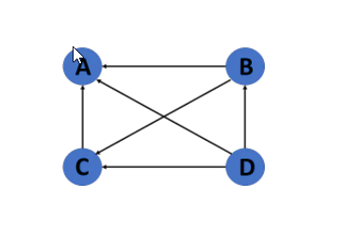

### Undirected Graph: - An undirected graph comprises a set of nodes and links connecting them. The order of the two connected vertices is irrelevant and has no direction. You can form an undirected graph with a finite number of vertices and edges.

### 